COPAC FAQs.
1)What are the different kinds of syntactical EDI errors that a carrier come across when they send their 996 data (Carrier ASN) to COPAC system?

Answer: There are different kinds of errors that can be encountered by the carriers. Please refer to the attached document for details on each error code.

Provided below are few examples.

Example 1:” TA1” Error
This is encountered if you have syntactical error in the ISA header(Envelope)
The carrier receives the below TA1 Error in return to their 996 sent to FORD incase if he has issue with the ISA header.
ISA~00~ ~00~ ~ZZ~F159B ~ZZ~JCOOP ~190225~1111~U~00200~000004436~0~p~<
TA1~000018352~190225~1102~R~020
IEA~00000~000004436
Please refer to the X12INTERCHANGE and TA1 errors.pdf listed above to determine the error code-Explanation.
TA1*000018352*190225*1102*R*020\-→This tells the user that the Test indicator he mentioned at the ISA15 segment is Invalid.
Here is the ISA header that GECHUB had received from the user-JCOOP.
ISA*00* *00* *ZZ*JCOOP *ZZ*F159B *190225*1101*U*00200*000018352*0*T*\-→At the ISA15 Element, the Test Indicator was mentioned as “T” instead of P, hence the carrier needs to change the ISA15 element from “T” to ”P”.

Error Example 2: TA1 Error 2:
The carrier receives the below TA1 Error in return to their 996 sent to FORD incase if he has issue with the ISA header.
ISA~00~ ~00~ ~ZZ~F159E ~ZZ~GP6DA ~180221~0205~U~00200~000000003~0~P~<?
TA1~000000004~180221~0137~R~008?
IEA~00000~000000003?
Please refer to the X12INTERCHANGE and TA1 errors.pdf listed above to determine the error Code-Explanation.
TA1~000000004~180221~0137~R~008? This tells the user that Invalid Interchange receiver ID mentioned at the ISA08 segment.
Here is the Actual message delivered to us:
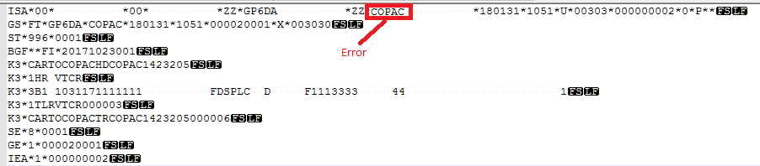

The Carrier needs to change the Envelope receiver code from COPAC to F159B on their ISA segment.
Should be changed to
ISA*00* *00* *ZZ*GP6DA *ZZ*F159B *180508*1753*U*00303*000000005*0*P*>?

Error Example 3: 997 Rejections:
Here is the actual message received
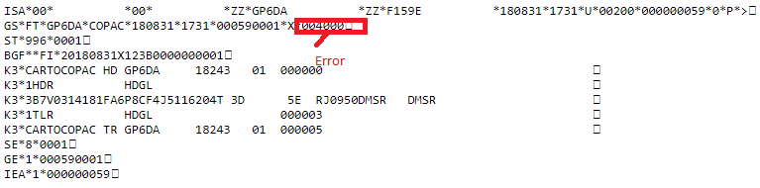
And the Rejected 997 Received by the carrier is
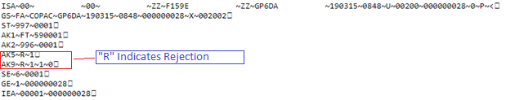
Please refer to the attached document 997.pdf for details on how to interpret the errors.
➢How to determine the error using the above attached 997.Pdf?
1)Interpret the segments AK5 and AK9 for the element which is causing the issue. In the above example.
AK5~R~1→It says that Refer the Data element-718 for the code-1-It indicates Transaction set not supported.
AK9~R~1~1~0→It says Num of transaction sets included is “1” ,Num of transactions set received is “1” and Num of transaction sets accepted is “0”.
The carrier gets “A” when his transaction is accepted at SOLMIS.
2)The error found in the above example was the transaction set “996” was not supported the version number-04000 and the correct version number to be mentioned is 003030.
Here is the corrected message:
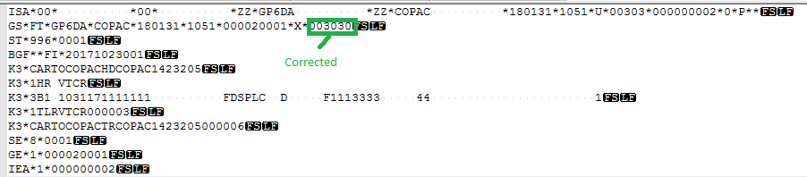

And the accepted 997 messages received by the carrier:
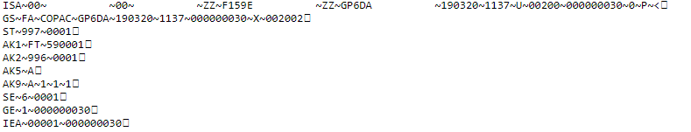
Error Example 4: New Line or Line feed character “Error”:
If you did not receive the 997 the transaction may have carriage return/Line feed

Issues with the new line(\n) or Line feed characters:

GECHUB does not process the data if there are any Line feed chanracters or New line characters(\n) in the data.

Option 1:Delete the Carriage return/Line feed characters in the message.

Option 2:Add the “STRIPLF” in their put command.

➢ If the data has line feeds and/or EBCDIC coded, either remove the line feeds and convert to ASCII format before sending, or "%STRIPLF%%%b" value in filename should be used in the ftp "put" command

ftp> put filename %STRIPLF%%%b
200 Command Okay.
150 File status okay; about to open data connection.
226 Transfer complete

Error Example 6: If you have sent 996 data and do not receive back a 997,Below are possible issues.
File name issues when Carrier send the data to GECHUB:

- Send an X12/EDIFACT to Production System

- If the Receiving Partner is ”F159B” in data, use the ”%F159B%” as parameter in the ftp "put" command

ftp> put filename %F159B%%%b
To make file unique please add datetimestamp when you are sending multiple ASN’s
%F159B%Datetimestamp or unique control number%%b
200 Command Okay.
150 File status okay; about to open data connection.

3) What are the possible COPAC System errors that come across carrier can receive when sending 996 data.
Answer: Here is one of the example that explains how to narrow down the COPAC errors.
Example 1:Invalid Exception codes:

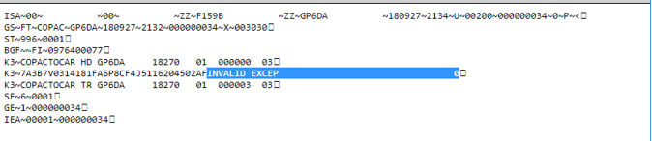

Here is the reason for the 2AF exception:

2AF | Invalid Exception Code | Exception code is not active, or, on COPAC database. The exception code is issued when an exception code is submitted but is the wrong code. Most likely the VIN is in a Final delivery status and requires a special code. Or the code is not in the exception code table (ex. V8 or E). Contact COPAC analyst.
Please refer to the attached document COPAC Error code.xls for COPAC error codes.

Example 2: SCAC code issue:

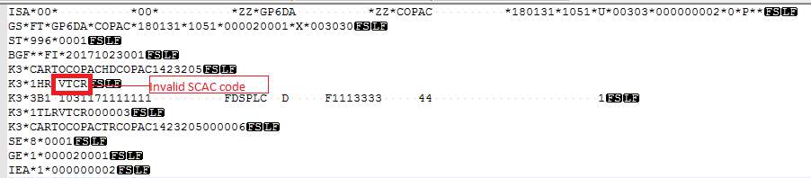
The Above SCAC code is validated at COPAC and it must be valid SCAC code.
Please follow the below instructions:
1.SCAC Code: If Carrier does not have SCAC Code, one will be assigned by COPAC group.
Please notify both contacts to coordinate the completion of a new SCAC code.
COPAC: Katricia Allen, at phone: 313-322-0915, kallen14@ford.com.
Systems Planning & Implementation (SP&I): Tammy Wilyard, at 313-337-6820, twilyard@ford.com
2.GSDB and SCAC assignment: Once the GSDB code is established, the COPAC team must contact Purchasing Information Management to associate the GSDB code to the assigned SCAC code so that CCAPS pays the carrier. If the carrier status does not show as 'Active 90 Status' the Ford Buyer must also submit a GSDB Change Request to GSDBOL@ford.com.

Action to be taken by the Carrier: Please correct the Scac code and Redeliver the data.
Example 3: Mismatch the number of records in between the K3-HD/HDR and K3-TR/TRL records.

Here is the actual message we received.
ISA*00* *00* *ZZ*GP6DA *ZZ*F159B *181101*0953*U*00200*000000068*0*P*>?
GS*FT*GP6DA*COPAC*181101*0953*000680001*X*003030?ST*996*0001?BGF**FI*20181101X123A0000000074?
K3*CARTOCOPAC HD GP6DA 18305 01 000000 ?
*1HDR HDGL ?
K3*3A5Q1022183LN6L5E96KR604981T 7TRJ01 ?
K3*3A5Q1022183LN6L5LU0KR605406T 7TRJ01 ?
K3*3A5Q1022183LN6L5MU1KR604621T 7TRJ01 ?
K3*1TLR HDGL 000003 -→Error 1
K3*CARTOCOPAC TR GP6DA 18305 01 000001-→Error 2
SE*10*0001?GE*1*000680001?IEA*1*000000068?

And the corrections are

ISA*00* *00* *ZZ*GP6DA *ZZ*F159B *181101*0953*U*00200*000000068*0*P*>?
GS*FT*GP6DA*COPAC*181101*0953*000680001*X*003030?ST*996*0001?BGF**FI*20181101X123A0000000074?
K3*CARTOCOPAC HD GP6DA 18305 01 000000 ?
*1HDR HDGL ?
K3*3A5Q1022183LN6L5E96KR604981T 7TRJ01 ?
K3*3A5Q1022183LN6L5LU0KR605406T 7TRJ01 ?
K3*3A5Q1022183LN6L5MU1KR604621T 7TRJ01 ?
K3*1TLR HDGL 000003--- Should be 5 (includes your Vins and header and trailer) ?
K3*CARTOCOPAC TR GP6DA 18305 01 000001 ----Should be 6 (includes all records) ?
SE*10*0001?GE*1*000680001?IEA*1*000000068?

Please see the attached document for more details on the Header and trailer counts.

5) I can't send 996s(COPAC Inbound 996s)? How can we get the support?

Answer:
- Has the user checked with their IT dept for any connectivity issues or application issues at the user's site?
  - Yes: Continue to the next step.
  - No: Direct user to check with their local IT dept.
- Is user having connectivity issues with Ford?
  - Yes: Continue to the next step.
  - No: Please direct the user to call Global Service Desk at 1-888-317-4957and record your request in an Incident Ticket for ITMS no-962.
- How does the user connect to Ford for their EDI Data?
  - VAN: Direct user to contact their VAN for assistance.
  - ANX: Direct Users to contact ANX.

6) I am not receiving Acknowledgement (997s) for 996s (COPAC Inbound 996’s) sent?

- How does the user connect to Ford for their EDI Data?
  - VAN: Direct user to contact their VAN for assistance getting a document re-queued.
  - ANX: Direct user to pull the data from Out Folder and the data is available here for 5 days and will be vanished as soon as the data is pulled by the carrier.
    - Data that has already been pulled and it was somehow missing at the carrier, He can still pull the data from the Archive folder and the data is available there for 15 Days after creation.
- If there are no issues wither at Van or ANX he usually connects then Please Direct the user to call Global Service Desk at 1-888-317-4957and record your request in an Incident Ticket for ITMS no-962.

